IMPORTANT NOTICE TO ALL NON-EU CUSTOMERS SENDING PRODUCTS AND SAMPLES TO THE UK

Element is constantly looking for ways to improve on its customer relationships and its customer experience. We believe one improvement would be the use of the IPR (Suspension) Scheme.

What is IPR (Suspension) Scheme?
It is an UK importing procedure that allows the import of Non-EU products and samples, to be tested by Element, and the re-export of these products and samples back to you, a Non-EU customer or your Non-EU end customer, without the upfront payment of UK import duty and UK VAT.

Why is this notice important to you?
In order for the UK Customs and Excise to allow the import of non EU products and samples under an approved IPR (Suspension) Scheme, UK Customs and Excise must be happy the goods are indeed intended for testing and will be re-exported at the end of the testing program.

Without sufficient information being made available to UK Customs and Excise by you at the time of import, the import will be processed as a normal import and the appropriate UK Import Duties, Agents Fees and UK VAT will be charged to element as the indicated importer. (As per the Consignment Note)

By following the IPR (Suspension) Scheme, your products and samples should clear UK Customs and Excise quickly and will reduce delays to your testing programs due to clearance issues that may normally arise.

Unfortunately where products and samples are not processed by UK Customs under the IPR (Suspension) Scheme, due to lack of sufficient information being submitted by the customer, the associated UK Import Duties & Agents Fees charged to Element will be passed back to you the customer resulting in an increase in costs to your testing programs.

Guidance for entering Products and Samples in to the UK for Testing
In order to enter goods under the IPR (Suspension) Scheme you must ensure that the following minimum information is included and given to your nominated shipping agent / courier:

- On the Consignment Note Include in “Other Notes / Special Delivery Instructions”:
“Product Samples for Testing only, Please Enter using CPC 51 00 001”
(Refer to Appendix 1 – Guidance on completing a TNT Consignment Note, for Japanese refer to Appendix 3)

- A Commercial Invoice must be included with the shipping documents. (See Appendix 2)
Important details that must appear on the commercial invoice are:
  - The Consignment Note Number
  - The appropriate Element site address. (If in doubt contact the element person who sent the quote.)
  - Element VAT Registration = GB174376290
  - A line by line detail of each type of item included in the shipment showing:
    - Qty of the Item/s
    - Full description of the item/s
    - The HS Tariff Code (Also referred to a the Harmonised Code)
    - Size of the Item/s
    - Total Value of the Item/s for Customs Purposes
      - For products and samples being returned at the end of the testing program, use your Material / Build costs of the products and samples. or;
      - Where the products are to be forwarded to your end customer at the end of the testing program, use the sales value as invoiced to the customer.

  - A Reason for Export to element under CPC 51 00 001, use one of the following sentences:
    - “The items included in this shipment are being exported to Element Materials Technology Warwick Ltd for compliance testing only. Once the testing is completed, the items will be re-exported back to the sender. Please enter under CPC5100001.” or;
    - “The items included in this shipment are being exported to Element Materials Technology Warwick Ltd for compliance testing only. Once the testing is completed, the items will be re-exported back to the senders end customer. Please enter under CPC5100001.”

Once completed, a scanned copy of the Consignment Note or Air Waybill and the Commercial Invoice must be e-mailed to the Element Contact relating to your project before the shipment is collected by your nominated shipping agent / courier.

Appendix 1 – Guidance on completing a TNT Consignment Note (For other shipping agents see additional information below)

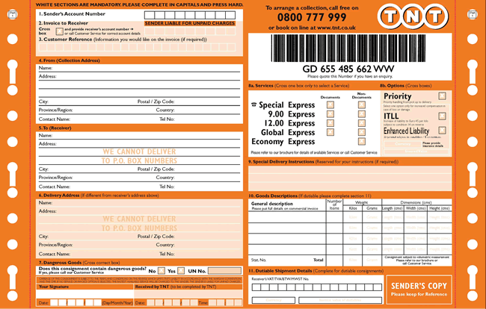

- Senders Account Number = your companies account number, you will be charged for the shipment to the UK directly by your shipping agent / courier.
- N/A
3) Customer Reference = enter the element Quote Number. (TRA-XXXXXX-XX)
4) From = full name and address, including postcode, of your company. (No PO Box addresses.)
5) To = the appropriate Element address, where the testing will take place, including postcode.
(If in doubt contact the element person who sent the quote.)
6) N/A = the appropriate Element address should be in section 5.
7) Dangerous Goods = A declaration must be made for every consignment including dangerous goods.
Contact your shipping agent / courier to discuss if required.
8) Required Service = Service to be charged is to be indicated by placing a cross in the appropriate boxes.
9) Special Delivery Instructions enter the following sentence:
“Product Samples for Testing by Element, Please Enter UK under CPC 51 00 001”
10) Number of items. This must match the number of items available for collection including:
The weight of the item(s) in grams/kilograms
The dimensions of the item(s) in centimetres
11) Sender's signature and date of collection.

Additional Note
All the main courier companies’ websites (TNT, DHL, FedEx etc) have detailed examples and guidance notes, in a variety of languages, on how to complete a Consignment Note. If you would like to refer to these sites and select your country:
DHL: www.dhl.com
TNT: www.tnt.com
FedEx: www.fedex.com
For other shipping agents refer to their main global website for assistance.

Appendix 2 – Template and Example on completing a Commercial Invoice

Overtype the required Data in the PINK CELLS (Remember to remove the pink shading before printing)

PRINT ON YOUR LETTER HEAD
Invoice

Invoice Number:
Invoice Date: | DD/MM/YYYY

Sender Details |  | Receiver Details
Company Name: |  | Company Name: | Element Materials Technology Warwick Ltd.
Company Address: |  | Address: | [Enter Appropriate Element Address]
Country: |  | Country: | United Kingdom
Registration: |  | Registration: | 02536659
Tax Number: |  | Tax Number: | GB174376290
Sender Contact |  | Receiver Contact
Name: |  | Name:
Telephone: |  | Telephone:
Email: |  | Email:

Qty | Full & Clear Description | HS Tariff Code |  |  |  |  |  |  |  |  |  | Country of Manufacturer |  |  | Unit Value | Currency | Total Value
Total Weight in Kg: |  |  |  |  |  |  |  |  |  |  |  |  |  | Sub Total
 |  |  |  |  |  |  |  |  |  |  |  |  |  | Insurance Premium (if applicable)
 |  |  |  |  |  |  |  |  |  |  |  |  |  | Freight Charges
 |  |  |  |  |  |  |  |  |  |  |  |  |  | Total Value

Number of Packages: |  | Consignment #:

Reason for Sending: The items included in this shipment are being exported to Element Materials Technology Warwick Ltd for compliance testing only. Once the testing is completed, the items will be re-exported back to the sender.
Please enter under CPC5100001

EORI Number if required is 000174376290

